1. Extract downloaded Eclipse into directory of choices (e.g. "c:\Program Files\Eclipse" on Windows).

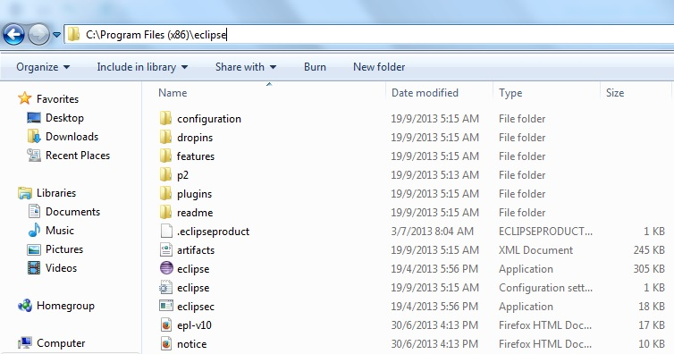

2. Import resource from local github repository

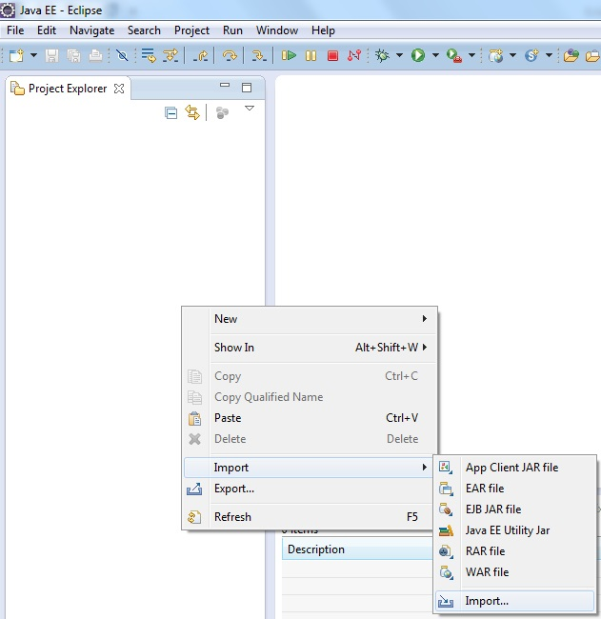

3. Select existing Maven Projects

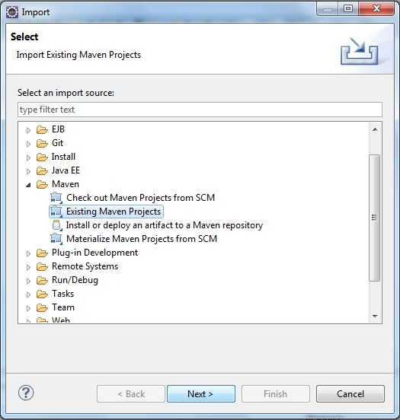

4. Browse for local repository directory.

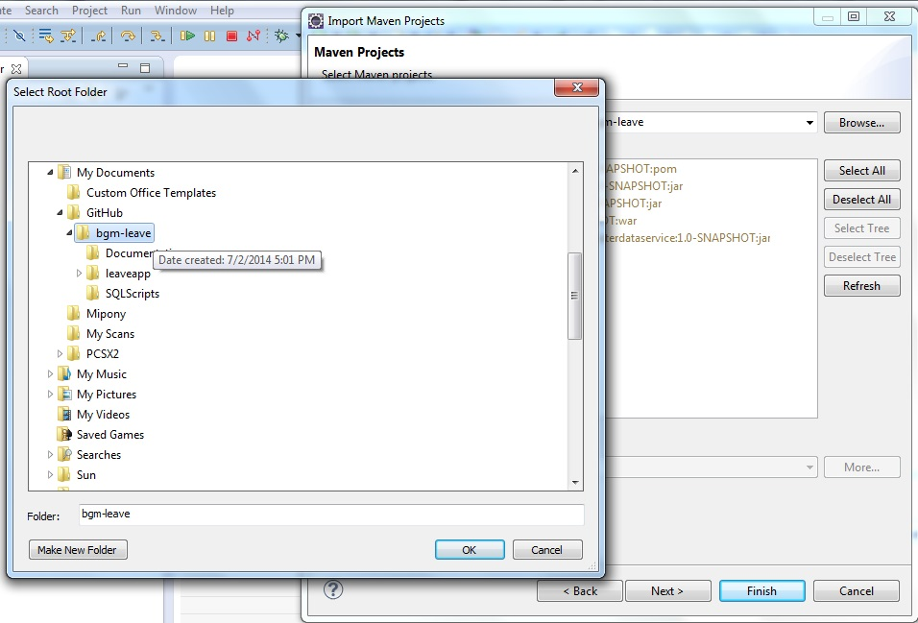

5. Resources will be detected if project are properly cloned from online git repository.

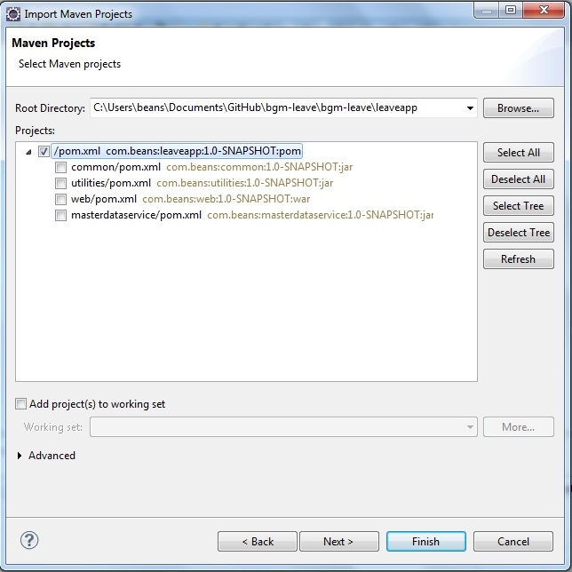

6. Finishing the import resources.

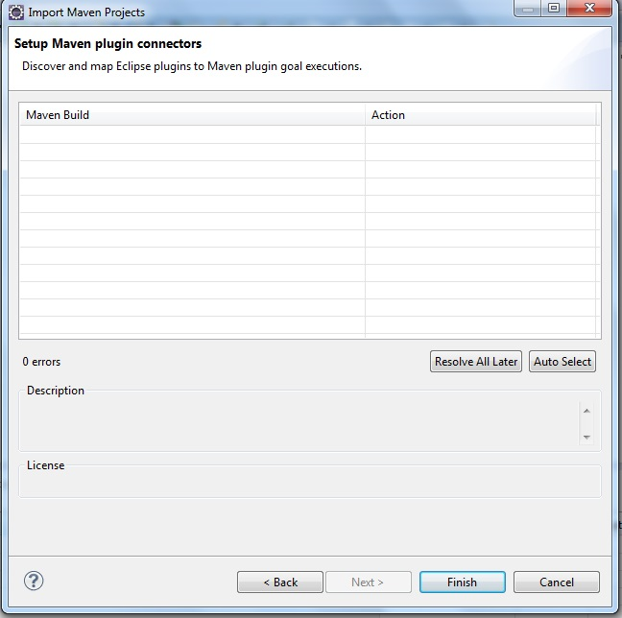

7. Successfully imported resource from local github repository.

